## ID Travel Group

### Set Up ID Travel Group

To partner with ID Travel Group,

Upon receiving login information, take the following steps to setup *ClientBase* for Live Connect.

**Step 1)** Create a Live Connect Provider for ID Travel Group if none exists by going to **Utilities|Live Connect Providers**, and clicking *Add*. (It’s a good idea to check if the URL is correct.)

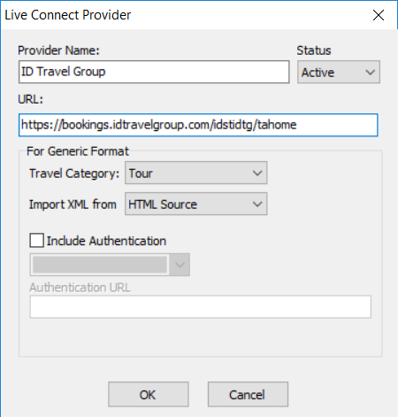

**Provider Name:** Enter **ID Travel Group**.

**URL:** Enter **https://bookings.idtravelgroup.com/idstidtg/tahome**

**Travel Category:** Select **Tour** from the drop-down menu.

**Import XML from:** Enter HTML Source.

**Step 2)** From the Profile Manager, retrieve the ID Travel Group profile (or create if not in database). From the General Info tab, click *Live Connect Providers*. Click *Add*, then select ID Travel Group from the drop-down list. The vendor code is **IDSTIDTG**. Click *OK*.

### Live Connect Features Supported by ID Travel Group

ID Travel Group supports the following Live Connect features if checked:

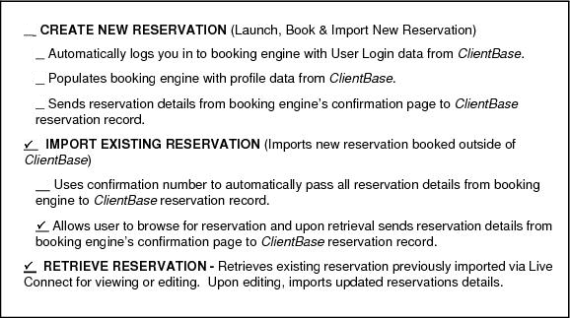

### 

### Importing an Existing Reservation

**Step 1)** Create a new Res Card Reservation**.** Enter the vendor name and click **Live Connect.** Confirm that the correct Provider is selected and click **Import an Existing Reservation**. Enter a confirmation number or leave blank and click **Okay**.

*Or*

**Step 1)** Open or create a new Res Card. Click **Live Connect** in the lower right corner of the Res Card screen. Select the Provider and click on **Import and Existing Reservation.** Enter a confirmation number or leave blank and click **Okay**.

**Step 2)** Depending on how the provider implemented this feature, you may be taken directly to the booking confirmation, or you may need to retrieve the reservation on the site.

**Step 3)** When the booking details are displayed, click **Import Reservation**.

All reservation data booked on-line is now located in the reservation fields in **ClientBase.**

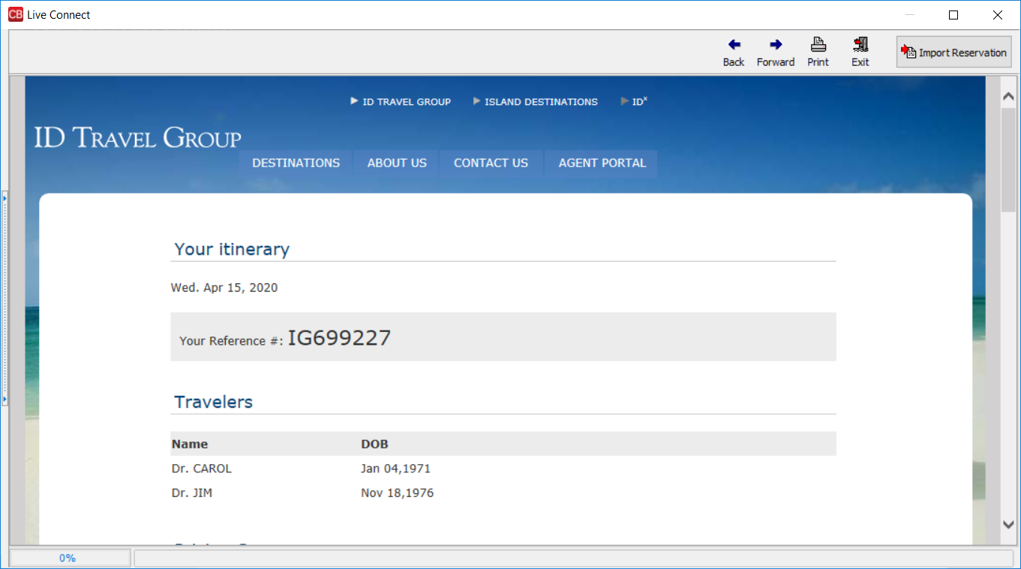

### Retrieve an Existing Reservation for Editing or Canceling

**Step 1)** Open your current Reservation and click on **Live Connect.** Click **Retrieve Reservation**.

**Step 2)** Depending on how the provider implemented this feature, you may be taken directly to the booking confirmation, or you may need to retrieve the reservation on the site.

**Step 2)** Edit or cancel the reservation using instructions supplied by the booking engine.

**Step 3)** When the reservation is confirmed and booking details displayed, click **Import Reservation**.

All reservation data edited or cancelled online is now located in the reservation fields in **ClientBase.**